**CALL-OUT**

**Dancers of all ages for THREADED FINE - Scotland**

**led by Rosemary Lee**

**May - June 2022**

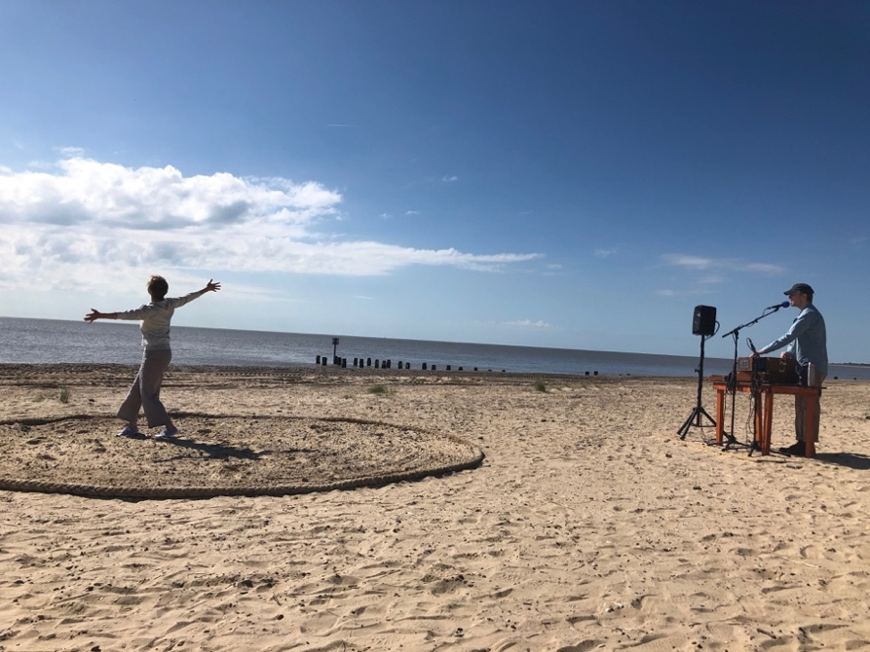

previous iteration on Lowestoft beach, 2019*

Working in partnership with **Dance North** and **Scottish Dance Theatre**, choreographer **Rosemary Lee** will be creating a durational performance - **THREADED FINE** -

for two outdoor locations in Findhorn and Dundee in June 2022.

Over five hours, 24 dancers ranging in age from 9-70yrs+ will perform the same 12-minute solo one after the other, starting with the youngest and ending with the oldest. Each dancer will bring their own quality to this repeating ritualistic performance accompanied by a song performed live by composer, singer Isaac Lee-Kronick. Audiences will be able to come and go or stay for the duration.

Following previous iterations in England (First Light Festival, Lowestoft) and Malta (ZfinMalta National Dance Theatre) Rosemary will be recreating this special project with a Scottish cast

in new terrains* in the coming few months. (*NB these new versions will be performed on grass)

Rosemary is looking for performers from both professional and non-professional backgrounds, based anywhere in Scotland. Through a series of selection workshops in Dundee and close to Findhorn, she is looking to cast 18 dancers whose ages fall between 9 - 18yrs and 35 - 70+yrs to join six Scottish Dance Theatre dancers for this special project.

Performers will receive an honorarium for their involvement (see information pack for details).

The most important requirement for this project is to love moving and dancing. It would also be useful if participants have some experience of dance, movement or performing in public. The creation process will involve an intensive weekend in Dundee in early May and then a weekly rehearsal in Dundee or Findhorn and the surrounding area depending on where you live.

Performances will take place during the first two weeks of June.

Continuing her passion for making large-scale intergenerational performances and films, Rosemary draws inspiration for this work from the cyclical rhythms of life that shape us whilst also highlighting the singular individuality of each performer. Known for her inclusive approach, she will nurture and enable each performer to find their particular quality for the solo.

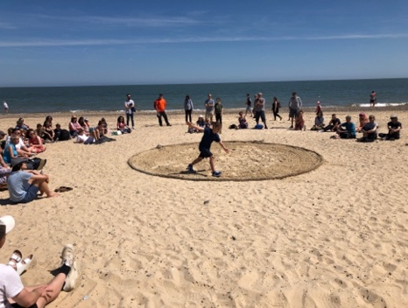 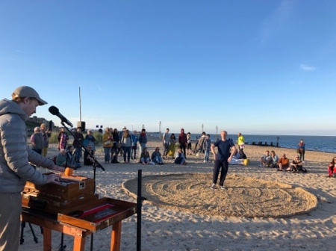 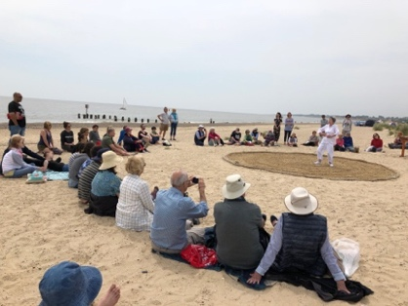

previous iteration on Lowestoft beach, 2019

If you are interested in being involved, please download the information pack from either [Dance North](mailto:Dance%20North) or [Scottish Dance Theatre’s](https://www.scottishdancetheatre.com/) website

or contact [rosemarylee@artsadmin.co.uk](mailto:rosemarylee@artsadmin.co.uk).

More information on Rosemary Lee can be found at <https://www.artsadmin.co.uk/profiles/rosemary-lee/>

Deadline for applications is 5pm Weds 9 March 2022

**Produced by** 

 

