Rosemary Lee’s

THREADED FINE – Scotland

INFORMATION PACK

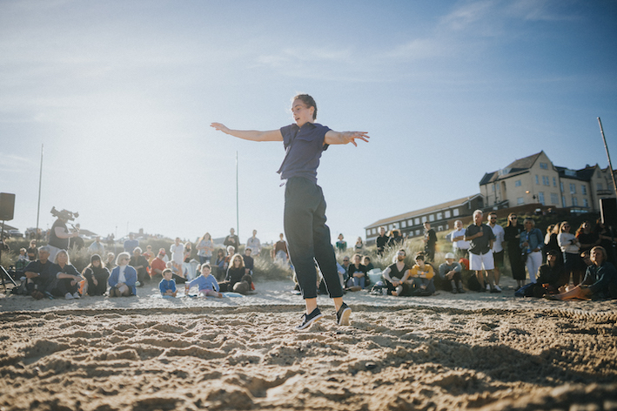
Matilda Lee-Kronick performing in Circadian (from which Threaded Fine has been developed) First Light Festival, 2019
Image © Mykola Romanovsky

Choreographer Rosemary Lee in partnership with Dance North and Scottish Dance Theatre is looking for performers to get involved in her work Threaded Fine.

Threaded Fine is a durational performance gathering a cast of up to 24 professional / non-professional dancers of all ages. The piece will be created and presented twice, in both Dundee and Findhorn in green outdoor sites. Over a period of 5 hours, 24 solos (lasting 12mins each) will be performed like a relay, one after the other starting with the youngest dancer and ending with the oldest.

Continuing her passion for making large-scale inter-generational performances, Rosemary takes inspiration from the rhythmic, cyclical nature of life we are all subject to whilst also highlighting the singular individuality of each dancer. The audience are welcome to come and go or stay for the whole duration.

Threaded Fine will be created over a period of about six weeks. During this time Rosemary will work individually with each performer within small groups, nurturing and enabling each performer to find their particular quality for the solo. Renowned for her inclusive approach, Rosemary values all performers equally and the creative process is both relaxed yet inspiring for everyone.

The performance will be accompanied by a specially commissioned sound-score by composer and singer Isaac Lee-Kronick which combines sections of pre-recorded and live music.

Rosemary writes – “Threaded Fine will be performed within a delineated circle in the centre of the green space that only the dancers can enter. I see it as a repeating, revolving, individual ritual in which moments of repetition and simplicity, intensity and stillness combine with the unique quality that each dancer brings to the solo.

There will be recognisable, repeating structures and movements but also tasks that each dancer will interpret slightly differently thus highlighting what inextricably binds us together and what makes each one of us distinct. I believe that dance as an art form can remind us of what it is to be human, to be alive in the moment.”

Whatever your age and experience, this will be a unique and memorable opportunity to work with an inspiring artist alongside a fantastic of range performers to create and perform an innovative and high-quality performance.

“I am looking for performers who love to move and dance, who are interested in embodying and exploring images and qualities, who are curious about the sensation and energetic state of the movements they explore, who enjoy dancing with a wide range of dynamics and qualities and who are unafraid to dance solo.

You would need to be able to commit fully to the rehearsal and performance schedule. Please get in touch to find out more.” Rosemary Lee

THE CAST
Although the most important requirement for this project is to love moving, it would be useful if participants have some experience of dance, movement or performing in public.

We are aiming to recruit the following approximate breakdown of performers:
6 performers 8 -18yrs
6 performers 35-55yrs
6 performers 55-70+yrs

The full cast will also include six company members of Scottish Dance Theatre

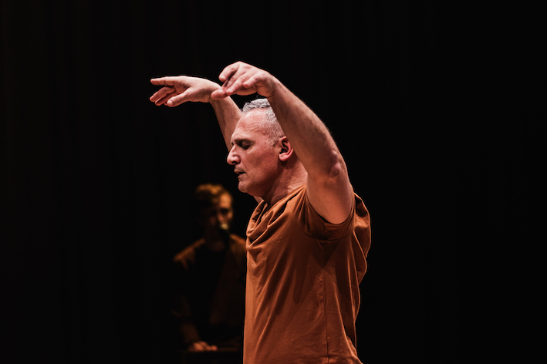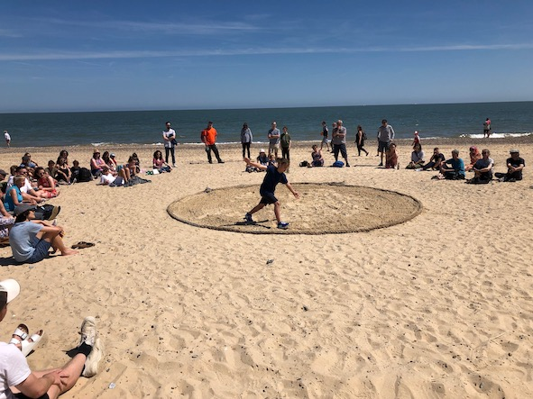

Threaded Fine: Zfin Malta 2020 indoor performance Circadian: First Light Festival 2019
image © Neil Grech Courtesy of ŻfinMalta

GETTING INVOLVED!

SELECTION PROCESS
To be considered for this project you should complete and submit the following documents:
- Application form
- Schedule Checklist
We will also accept Video and Audio applications.

Please note there is no need to submit a professional CV or dance showreel

See WHAT YOU SHOULD DO NEXT
You will then be invited to attend a cast selection workshop on one of the following dates and locations:

Findhorn
Thursday March 17 6 - 8.30pm adults 35-59yrs
Friday March 18 2 - 4.30pm young people
6 - 8.30pm adults 60+yrs
Dundee
Saturday March 19 2.30 - 5pm young people
Sunday March 20 10.30 - 1pm adults 35-59yrs
2.30 - 5pm adults 60+yrs

(Please note this may be adapted depending on who applies)

Confirmation of Cast:

The final cast will be selected according to the criteria that Rosemary has deemed important for the choreography: imagination, expressivity, performance quality commitment whilst reflecting a range of ages, backgrounds and genders.
Everyone will notified of the final selection by 28 March 2022.

THE CREATIVE PROCESS

You will need to be able to commit to the following rehearsals in order to be considered for this project.

We have included all dates below but please note that each performer will only be required to attend
- Full cast workshop-rehearsals on 7/8 / 21 or 22 May, 8 June (half-full days)
- x 4 small group weekly rehearsals (3hrs each between 9 May -3 June)
- 9/10/16/17 June half-days for technical/dress rehearsals
- 11/18 June Performances (afternoon/evening)

Rehearsal and Performance Schedule

Please note changes might occur due to the make-up and location of the final cast.
Children’s weekly rehearsals are likely to be shorter.

Full cast
Saturday 7 May 2 - 6.30pm Dundee
Sunday 8 May 10am - 3.00pm Dundee

Saturday 21 May 10.30am - 3.30pm (performers nearest Findhorn)
or
Sunday 22 May 10.30am - 3.30pm (performers nearest Dundee)

Performers nearest Dundee
will be required to attend 4 rehearsals on either a Monday, Tuesday or Wednesday evening

Mondays 9/16/23/30 May 6 - 9pm in studio and on site in Dundee
Tuesdays May 10/17/24/31 6 - 9pm in studio or on site in Dundee
Wednesdays 11/18/25 May & 1 June 6 - 9pm in studio or on site in Dundee

Performers nearest Findhorn
will be required to attend 4 rehearsals on either a Thursday or Friday afternoon or evening

Thursday 12/19/26 May 12 & 2 June* 6-9pm in studio and on site near Findhorn
Fridays 13/20/27 May & 3 June* 2-5pm young people in studio and on site near Findhorn
Fridays 13/20/27 May & 3 June* 6-9pm in studio and on site near Findhorn
*NB 2/3 June rehearsals are on are Bank Holidays

Performance weeks - Full cast
All 24 dancers will take part in the final performances in both Dundee and Findhorn)

FINDHORN
Wednesday June 8 all day (times tbc)
Thurs June 9 Tech rehearsals (times tbc)
Friday June 10 Dress rehearsal (times tbc)
Saturday June 11 PERFORMANCE afternoon evening

DUNDEE
Thursday 16 June Tech (afternoon/evening times to be confirmed)
Friday 17 June Dress rehearsal (times to be confirmed)
Saturday 18 June PERFORMANCE afternoon evening

HONORARIUM

Each cast member will receive an honorarium according to age range:

9-13 yrs £425

14-18 yrs £645

35-59 yrs £1,345

60+yrs £720

TRAVEL & TRANSPORT
Performers will need to make their own travel arrangements to rehearsals and performances and organise their own accommodation.
We can offer details of travel options (incl car-shares/lifts) and local accommodation if required.
We have a travel and accommodation fund, which will be allocated on a case-by-case basis depending on the need.

ACCESS
We can offer financial and practical help to support your access needs but please bear in mind the conditions as described above. Please also take into consideration:

- Some rehearsals and the performances will be taking place outside on grass.
- In the performances, you will be dancing alone in a circular area with the audience all around you.
- You will be learning set material, responding to and exploring tasks and very clear instructions guided and supported by Rosemary and the project team.
- You will be mostly rehearsing your solo in small groups so you will get individual attention. Sometimes you will be meeting and working together as a big ensemble of 24 people.
- Each solo will be approx. 9-10 mins long. Rosemary will work with each individual to make any choreographic adaptations if required.
- The rehearsal spaces in Dundee and Findhorn will be fully accessible.

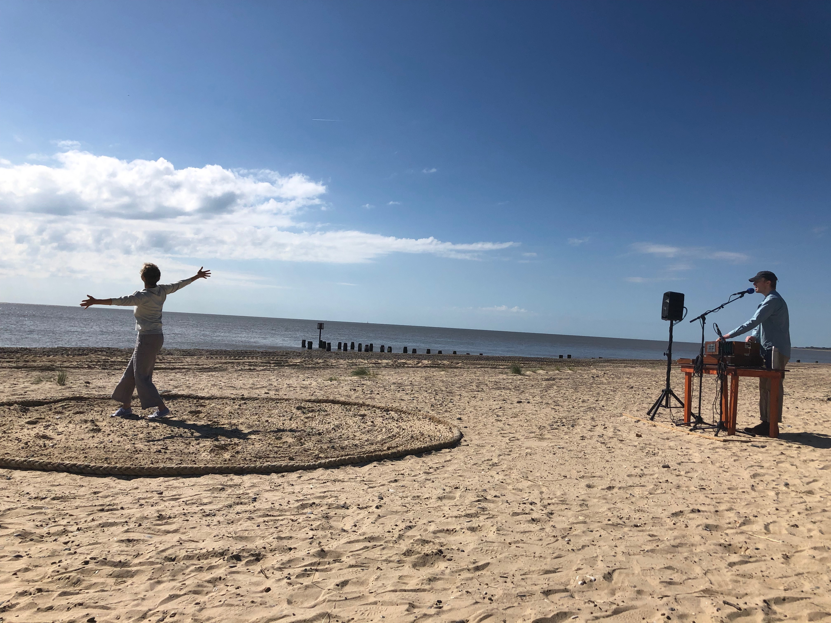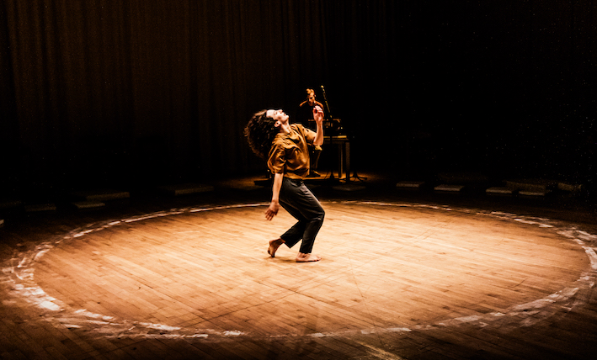
Circadian: First Light Festival 2019 Threaded Fine: Zfin Malta 2020 indoor performance image ©

WHAT YOU SHOULD DO NEXT

If you are interested in getting involved, please complete Application Form and Schedule Checklist or send video /audio files to rosemarylee@artsadmin.co.uk

If you prefer to print your application, you can send it by regular post to:
Tashi Gore OR Gail Sneddon
Dundee Rep and Scottish Dance Theatre Dance North
Tay Square Findhorn Hive
Dundee DD1 1PB 567 West Whins
Findhorn IV36 3SH

If you are under 18, a parent/guardian must complete section 3 of the form.

Application Deadline is 5pm on Weds 9 March 2022

If you have any questions regarding the project, please contact rosemarylee@artsadmin.co.uk

This information is also available in large print format.

Rosemary Lee and the project partners reserve the right to change any information or conditions stated above.

ABOUT

Rosemary Lee
Known for working in a variety of contexts and media, Rosemary creates large-scale site-specific works with cross-generational casts, solos for herself and other performers, video installations and short films. Her work is characterised by an interest in creating a moving portraiture of the performing individuals and communities she brings together, whilst also exploring and highlighting our relationship with our environment.

Her recent work includes Square Dances (Dance Umbrella) involving 150 performers in four London squares, Under the Vaulted Sky - a promenade work for 80 participants in a cathedral of trees for Milton Keynes International Festival, Liquid Gold is the Air (created with Roswitha Chesher)- an award winning video installation touring cathedrals and galleries, Without, a seven-screen video installation capturing a panoramic view of the city of Derry/Londonderry as hundreds of participants move through the streets, Calling Tree (co directed with Simon Whitehead) which takes place in the canopies of urban trees, and Passage for Par(Groundwork, Cornwall) a durational work for 30 women slowly crossing tidal sands and Circadian (First Light Suffolk), the mother work to Threaded Fine first performed in Malta with ZfinMalta National Dance Company.

Rosemary’s work is produced by Artsadmin.
She is also a Senior Research Fellow at C-DaRE Coventry University, holds an Honorary Doctorate from Roehampton University, and has an Honorary Fellowship from Trinity Laban.
rosemarylee

What stays with me …is that I hold in my body the same dance as all the young people hold is theirs and it will stay with them for a lifetime.

Josephine Burden oldest performer in Threaded Fine Malta 2020

Dance North
Dance North brings excellent, often challenging work, to rural northeast Scotland, drawing artists and choreographers from across the globe. Whether it’s introducing rural audiences to contemporary dance, promoting experimental dance practices or delivering dance and movement workshops to improve health and wellbeing, we advocate for dance throughout our communities
dancenorth

Scottish Dance Theatre
Led by Artistic Director Joan Clevillé, Scottish Dance Theatre creates dance that is engaging and engaged. The company’s artistic vision is driven by artistic exploration, learning, and a desire to connect with others.
The company is one of the few full-time ensembles in the UK and is made up of a group of inquisitive and versatile dancers who have come from all over the world to work and create at Dundee Rep Theatre. Working at the forefront of the art form, Scottish Dance Theatre collaborates with internationally acclaimed choreographers and artists, supports the development of emerging and home-grown talent and promotes a plurality of voices.
For more than thirty years, the company has brought unique dance experiences to audiences and communities across Scotland, the UK and abroad, producing dance that is thought provoking and holds resonance in people’s lives. Scottish Dance Theatre has received multiple awards (including the Critics’ Circle National Dance Award for Outstanding Company Repertoire), and has built a strong international profile, becoming Scotland’s flagship dance company and a creative ambassador of Dundee.
scottishdancetheatre.com

Produced by

